Мое
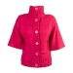 | F&F Kimono sleeve cape Product code: 5052003661868 Colour: Pink Size: 14 |  | £8.00 |  | 1 |  | £8.00

