Кузенька
ДД
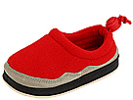Foamtreads Kids: Tin Tin (Infant/Toddler/Youth)
SKU# 7306872
Color: Red
size: 5 Infant
width: M
$5.70
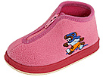Foamtreads Kids: Huggys (Infant/Toddler)
SKU# 7393914
Color: Pink
size: 5 Infant
width: M
$6.63
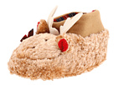 | Baby Deer: Faux Fur Moose Slippers (Infant)  SKU# 7752275  Color: Brown  size: LG (12-18 Months)  width: M | $6.50

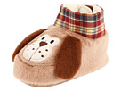 | Baby Deer: Faux Fur Dog Slippers (Infant)  SKU# 7752281  Color: Brown  size: LG (12-18 Months)  width: M | $6.50
Итого: 25,33+1(шип)=26,33*31,1=788руб

