Мое
ДД
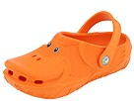
Polliwalks: Duck (Infant/Toddler/Youth)  SKU# 7617254  Color: Orange  size: 4 Infant  width: M
  $4.31
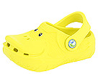 | Polliwalks: Duck (Infant/Toddler/Youth)  SKU# 7617254  Color: Lemon  size: 4 Infant  width: M | $4.31

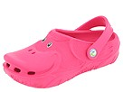 | Polliwalks: Duck (Infant/Toddler/Youth)  SKU# 7617254  Color: Fuchsia  size: 5 Infant  width: M | $4.31

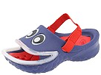 | Polliwalks: Fish Lips (Infant/Toddler/Youth)  SKU# 7617604  Color: Blue  size: 5 Infant  width: M | $4.31

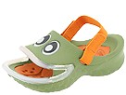 | Polliwalks: Fish Lips (Infant/Toddler/Youth)  SKU# 7617604  Color: Army  size: 5 Infant  width: M | $4.31

Итого:21,55+1(шип)=22,55*31,1=701руб

